Exercise 1: Configuring a Basic Spring Application
Scenario:
Your company is developing a web application for managing a library. You need to use the Spring Framework to handle the backend operations.
Steps:
- Set Up a Spring Project:
  - Create a Maven project named LibraryManagement.
  - Add Spring Core dependencies in the pom.xml file.
- Configure the Application Context:
  - Create an XML configuration file named applicationContext.xml in the src/main/resources directory.
  - Define beans for BookService and BookRepository in the XML file.
- Define Service and Repository Classes:
  - Create a package com.library.service and add a class BookService.
  - Create a package com.library.repository and add a class BookRepository.
- Run the Application:
  - Create a main class to load the Spring context and test the configuration.
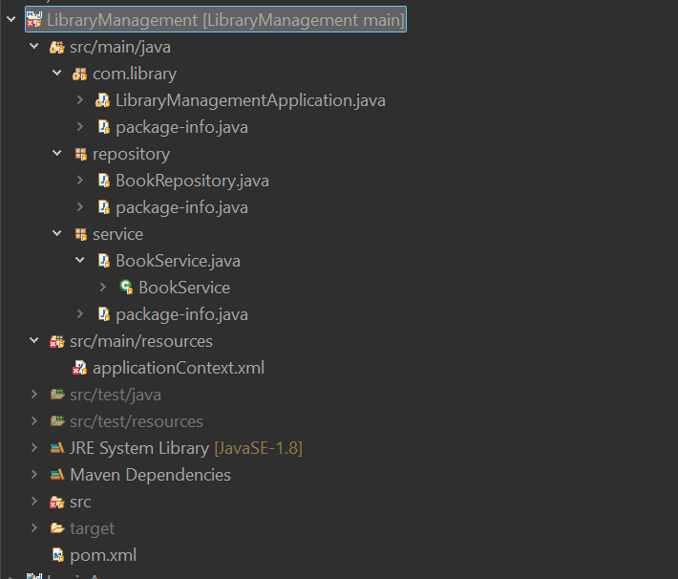

<?xml version="1.0" encoding="UTF-8"?>

<beans xmlns="http://www.springframework.org/schema/beans"
xmlns:xsi="http://www.w3.org/2001/XMLSchema-instance"
xsi:schemaLocation="
http://www.springframework.org/schema/beans
https://www.springframework.org/schema/beans/spring-beans.xsd">

<bean id="bookRepository"
class="repository.BookRepository"/>

<bean id="bookService"
class="service.BookService">

<property name="repository"
ref="bookRepository"/>

</bean>

</beans>

package repository;

public class BookRepository {

public void showBooks() {
System.out.println("Fetching books from the database");
}

}

Exercise 2: Implementing Dependency Injection
Scenario:
In the library management application, you need to manage the dependencies between the BookService and BookRepository classes using Spring's IoC and DI.
Steps:
- Modify the XML Configuration:
  - Update applicationContext.xml to wire BookRepository into BookService.
- Update the BookService Class:
  - Ensure that BookService class has a setter method for BookRepository.
- Test the Configuration:
  - Run the LibraryManagementApplication main class to verify the dependency injection.
Dependency injection:
package service;
import repository.BookRepository;

public class BookService {
private BookRepository br;
public void setRepository(BookRepository br) {
this.br = br;
}
public void displayBooks() {
br.showBooks();
}

}

Output:
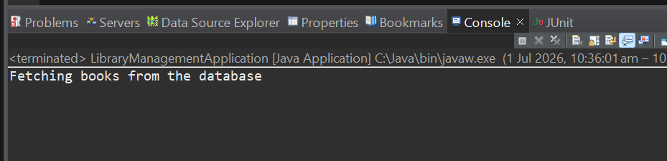

Exercise 4: Creating and Configuring a Maven Project
Scenario:
You need to set up a new Maven project for the library management application and add Spring dependencies.
Steps:
- Create a New Maven Project:
  - Create a new Maven project named LibraryManagement.
- Add Spring Dependencies in pom.xml:
Include dependencies for Spring Context, Spring AOP, and Spring WebMVC.
<dependencies>
<dependency>
<groupId>org.springframework</groupId>
<artifactId>spring-context</artifactId>
<version>5.3.39</version>
</dependency>
<dependency>
<groupId>org.springframework</groupId>
<artifactId>spring-aop</artifactId>
<version>5.3.39</version>
</dependency>
<dependency>
<groupId>org.springframework</groupId>
<artifactId>spring-webmvc</artifactId>
<version>5.3.39</version>
</dependency>

</dependencies>

- Configure Maven Plugins:
Configure the Maven Compiler Plugin for Java version 1.8 in the pom.xml
<project xmlns="http://maven.apache.org/POM/4.0.0" xmlns:xsi="http://www.w3.org/2001/XMLSchema-instance" xsi:schemaLocation="http://maven.apache.org/POM/4.0.0 https://maven.apache.org/xsd/maven-4.0.0.xsd">
<modelVersion>4.0.0</modelVersion>
<groupId>com.library</groupId>
<artifactId>LibraryManagement</artifactId>
<version>0.0.1-SNAPSHOT</version>

<properties>
<maven.compiler.source>17</maven.compiler.source>
<maven.compiler.target>17</maven.compiler.target>
</properties>
<dependencies>
<dependency>
<groupId>org.springframework</groupId>
<artifactId>spring-context</artifactId>
<version>5.3.39</version>
</dependency>
<dependency>
<groupId>org.springframework</groupId>
<artifactId>spring-aop</artifactId>
<version>5.3.39</version>
</dependency>
<dependency>
<groupId>org.springframework</groupId>
<artifactId>spring-webmvc</artifactId>
<version>5.3.39</version>
</dependency>

</dependencies>
</project>

